**Lab 02.2: Business Process Flows and Business Rules**

In this lab you will enhance the data model and improve the app behavior by adding a business process flow and a business rule.

**What you will learn**

* How to identify stages in a Business Process Flow (BPF)
* How to create and use a BPF
* How to use a business rule to implement logic

**High-level lab steps**

* Exercise 1 – Create BPF lifecycle of problem report
  + Route
  + Fix
  + Resolved
* Exercise 2 – Business rule to not allow close without resolution

**Prerequisites**

* Must have completed **Lab 02.1: Data model and model-driven app**

**Detailed steps**

**Exercise 1: Create business process flow**

In this exercise, you will create a business process flow for the problem report table.

**Task 1: Customize Table**

In this task, you will add a lookup Column to the problem report table.

1. Navigate to the [Power Apps maker portal](https://make.powerapps.com/) page and make sure you are in the correct environment.
2. Select **Solutions** and click to open the **Company 311** solution.
3. Locate and click to open the **Problem Report** table.
4. Click **+ New**, then click **Column**.
5. Enter **Assign to** for **Display name**, select **Lookup** for **Data type**, select **User** for **Related table**, and click **Save**.

[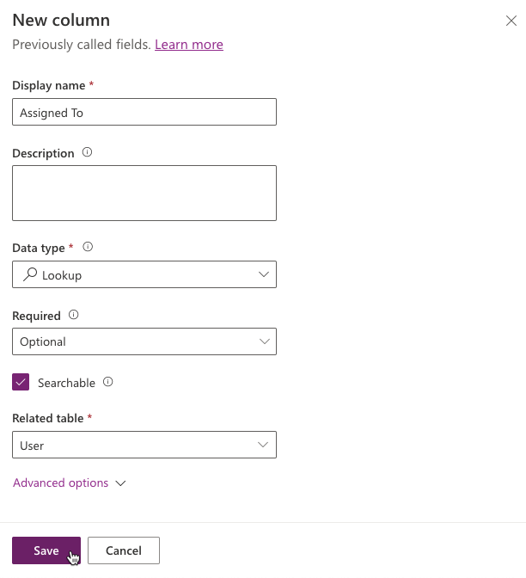](https://github.com/MicrosoftLearning/PL-100-Microsoft-Power-Platform-App-Maker/blob/master/Instructions/Labs/02-2/media/image1.png)

1. Select **All** in the **Objects** navigation tree.
2. Click **Publish all customizations** and wait for the publishing to complete.

**Task 2: Create business process flow**

In this task, you will create a business process flow for the Problem Report table.

1. Navigate to the [Power Apps maker portal](https://make.powerapps.com/) page and make sure you are in the correct environment.
2. Select **Solutions** and click to open the **Company 311** solution.
3. Click **+ New > Automation > Process > Business process flow**.

[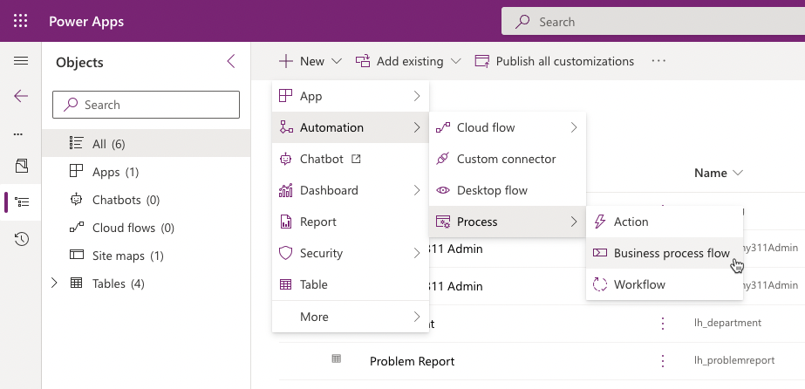](https://github.com/MicrosoftLearning/PL-100-Microsoft-Power-Platform-App-Maker/blob/master/Instructions/Labs/02-2/media/image2.png)

1. In the **New busines process flow** panel enter **Problem resolution process** for **Display name**, select **Problem Report** for **Table**, and click **Create**.

[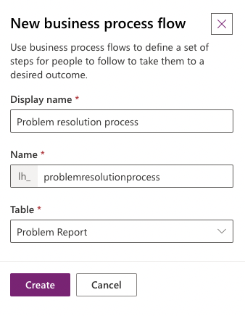](https://github.com/MicrosoftLearning/PL-100-Microsoft-Power-Platform-App-Maker/blob/master/Instructions/Labs/02-2/media/image3.png)

1. Select the **New stage**, go to the **Properties** pane, change the **Display Name** to **Route**, and click **Apply**.

[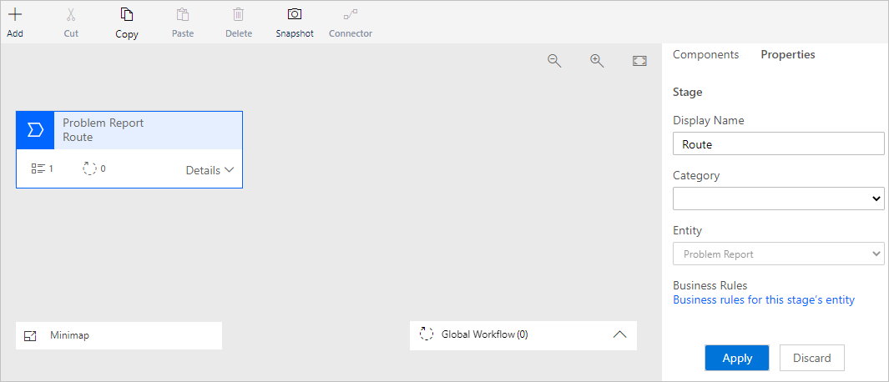](https://github.com/MicrosoftLearning/PL-100-Microsoft-Power-Platform-App-Maker/blob/master/Instructions/Labs/02-2/media/image4.png)

1. Expand **Details** of the **Route** stage.

[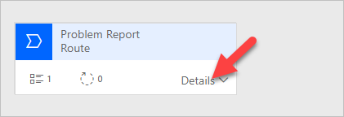](https://github.com/MicrosoftLearning/PL-100-Microsoft-Power-Platform-App-Maker/blob/master/Instructions/Labs/02-2/media/image5.png)

1. Select **Data Step #1**, go to the **Properties** pane, select **Building** for **Data Field**, and click **Apply**.

[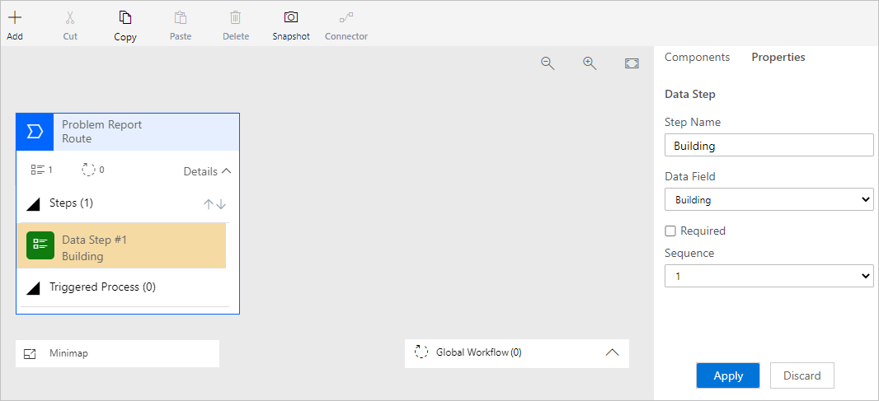](https://github.com/MicrosoftLearning/PL-100-Microsoft-Power-Platform-App-Maker/blob/master/Instructions/Labs/02-2/media/image6.png)

1. Click **+ Add** and select **Add Data Step**.

[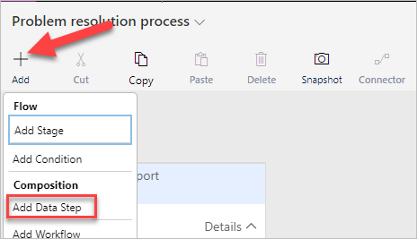](https://github.com/MicrosoftLearning/PL-100-Microsoft-Power-Platform-App-Maker/blob/master/Instructions/Labs/02-2/media/image7.png)

1. Select the **+** option to add the data step below the **Building** data step.

[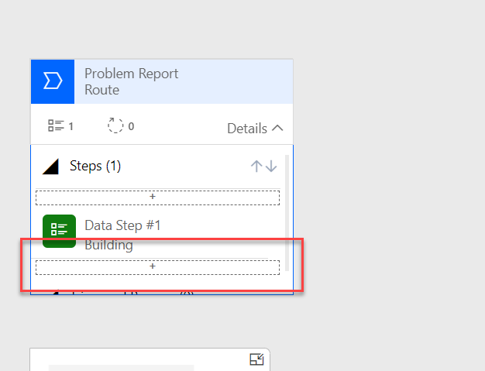](https://github.com/MicrosoftLearning/PL-100-Microsoft-Power-Platform-App-Maker/blob/master/Instructions/Labs/02-2/media/image27.png)

1. Select the new data step, go to the **Properties** pane, select **Location** for **Data Field**, and click **Apply**.
2. Click **+ Add** again and select **Add Data Step**.
3. Select the new data step, go to the **Properties** pane, select **Department** for **Data Field**, and click **Apply**.
4. The **Route** stage should now look like the image below.

[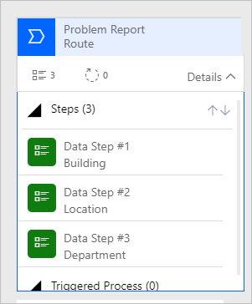](https://github.com/MicrosoftLearning/PL-100-Microsoft-Power-Platform-App-Maker/blob/master/Instructions/Labs/02-2/media/image8.png)

1. Click **+ Add** and select **Add Stage**.
2. Add the new stage after the **Route** stage.
3. Select the stage, go to the **Properties** pane, enter **Fix** for **Display Name**, and click **Apply**.
4. Expand **Details** of the **Fix** stage.
5. Select **Data Step #1** of the **Fix** stage.
6. Go to the **Properties** pane, select **Assign to** for **Data Field** and click **Apply**.
7. Click **+ Add** and select **Add Stage**.
8. Add the new stage after the **Fix** stage.
9. Select the new stage, go to the **Properties** pane, enter **Resolve** for **Display Name** and click **Apply**.
10. Expand **Details** of the **Resolve** stage.
11. Select **Data Step #1** of the **Resolve** stage.
12. Go to the **Properties** pane, select **Resolution** for **Data Field** and click **Apply**.
13. Click **+ Add** and select **Add Data Step**.
14. Add the new data step below the **Resolution** data step.
15. Select the new data step, go to the **Properties** pane, select **Resolved on** for **Date Field** and click **Apply**.
16. The Business process flow should now look like the image below. Click **Save**.

[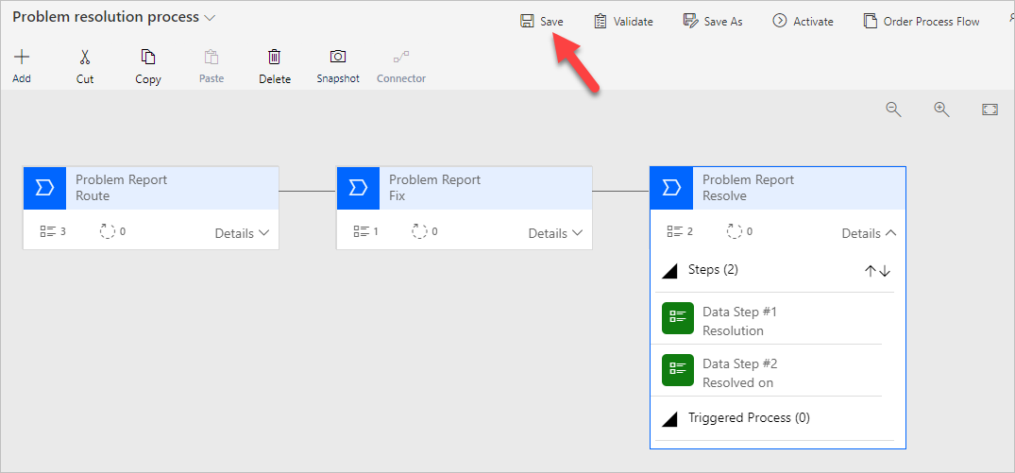](https://github.com/MicrosoftLearning/PL-100-Microsoft-Power-Platform-App-Maker/blob/master/Instructions/Labs/02-2/media/image9.png)

1. Click **Activate**.
2. Click **Activate** again on the pop-up.
3. Confirm that **Status: Active** on the bottom-left side of the screen.

[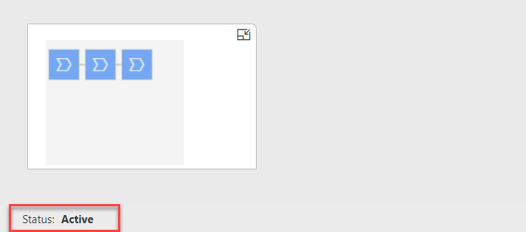](https://github.com/MicrosoftLearning/PL-100-Microsoft-Power-Platform-App-Maker/blob/master/Instructions/Labs/02-2/media/image28.png)

1. Close the process editor browser window or tab.
2. Click **Done**.

**Exercise 2: Create business rule**

In this exercise, you will create a business rule that will block completion of problems without resolution.

**Task 1: Create business rule**

1. Navigate to the [Power Apps maker portal](https://make.powerapps.com/) page and make sure you are in the correct environment.
2. Select **Solutions** and click to open the **Company 311** solution.
3. Locate and click to open the **Problem Report** Table.
4. Select the **Business rules** tab and click **Add business rule**.

[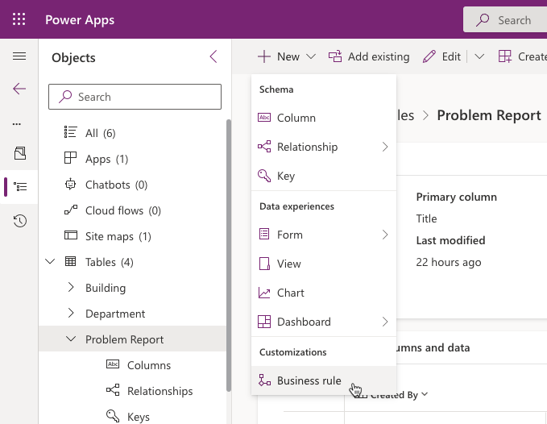](https://github.com/MicrosoftLearning/PL-100-Microsoft-Power-Platform-App-Maker/blob/master/Instructions/Labs/02-2/media/image12.png)

1. Make sure the **Scope** is set to **Entity** and click **Show details** chevron.

[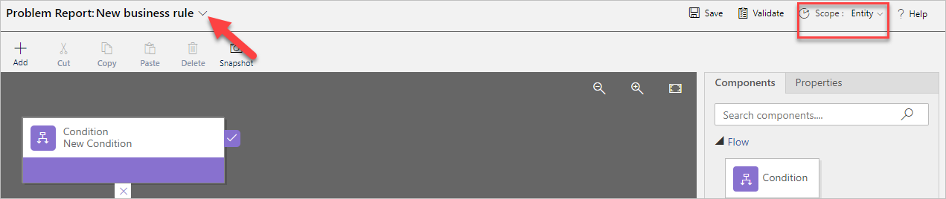](https://github.com/MicrosoftLearning/PL-100-Microsoft-Power-Platform-App-Maker/blob/master/Instructions/Labs/02-2/media/image13.png)

1. Change **Business rule name** to **Completion rule** and click **Hide details** chev

[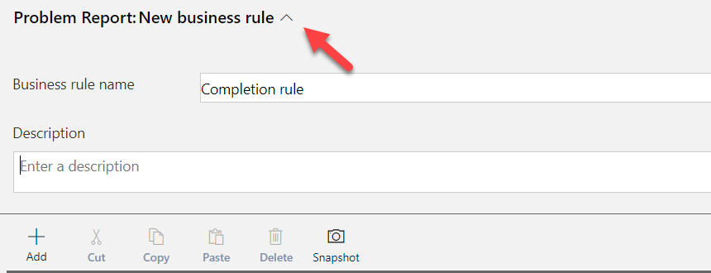](https://github.com/MicrosoftLearning/PL-100-Microsoft-Power-Platform-App-Maker/blob/master/Instructions/Labs/02-2/media/image29.png)

1. Select the **Condition**.
2. Go to the **Properties** pane and change the **Display name** to **Resolution required**.
3. Scroll down to **Rule 1**, select **Status Reason** for **Field**, select **Equals** for **Operator**, select **Value** for **Type**, select **Completed** for **Value**, and click **Apply**.

[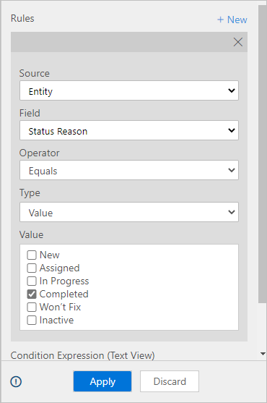](https://github.com/MicrosoftLearning/PL-100-Microsoft-Power-Platform-App-Maker/blob/master/Instructions/Labs/02-2/media/image14.png)

1. Click **+ New**.

[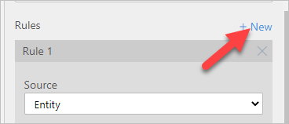](https://github.com/MicrosoftLearning/PL-100-Microsoft-Power-Platform-App-Maker/blob/master/Instructions/Labs/02-2/media/image15.png)

1. Scroll down to **Rule 2**, select **Resolution** for **Field**, select **Does not contain data** for **Operator**, make sure **And** is selected for **Rule Logic**, and click **Apply**.

[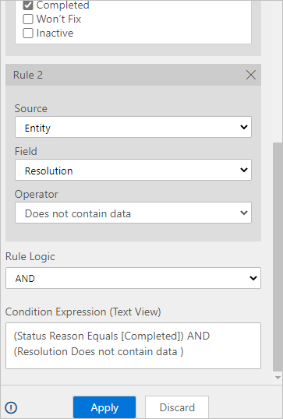](https://github.com/MicrosoftLearning/PL-100-Microsoft-Power-Platform-App-Maker/blob/master/Instructions/Labs/02-2/media/image16.png)

1. Click **+ Add**.

[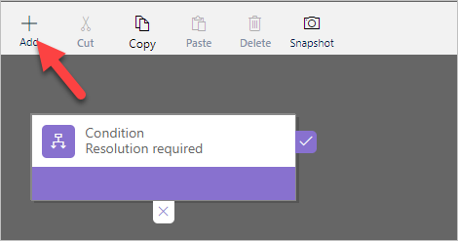](https://github.com/MicrosoftLearning/PL-100-Microsoft-Power-Platform-App-Maker/blob/master/Instructions/Labs/02-2/media/image17.png)

1. Select **Add show error message**.
2. Add the action on the **true** path of the condition.

[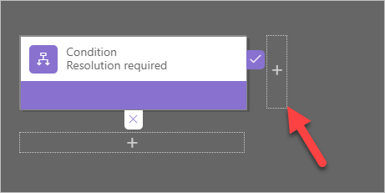](https://github.com/MicrosoftLearning/PL-100-Microsoft-Power-Platform-App-Maker/blob/master/Instructions/Labs/02-2/media/image18.png)

1. Select the new action, go to the **Properties** pane, enter **Show message** for **Display Name**, select **Status Reason** for **Field**, enter **The Problem must have a resolution before it can be closed** for **Message**, and click **Apply**.

[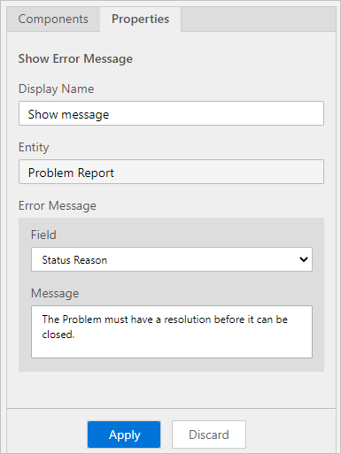](https://github.com/MicrosoftLearning/PL-100-Microsoft-Power-Platform-App-Maker/blob/master/Instructions/Labs/02-2/media/image19.png)

1. The business rule should now look like the image below. Click **Save**.

[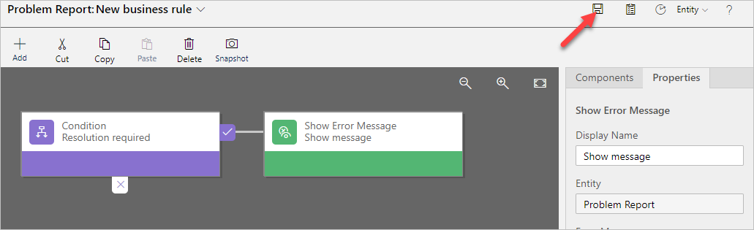](https://github.com/MicrosoftLearning/PL-100-Microsoft-Power-Platform-App-Maker/blob/master/Instructions/Labs/02-2/media/image20.png)

1. Click **Activate**.
2. Click **Activate** again on the pop-up.
3. Confirm activation.
4. Close the process editor browser window or tab.
5. Click **Done**.

**Exercise 3: Test processes**

In this exercise, you will test the business process flow and the business rule you created.

**Task 1: Test processes**

1. Navigate to the [Power Apps maker portal](https://make.powerapps.com/) page and make sure you are in the correct environment.
2. Select **Apps** and click to open the **Company 311 Admin** application.

[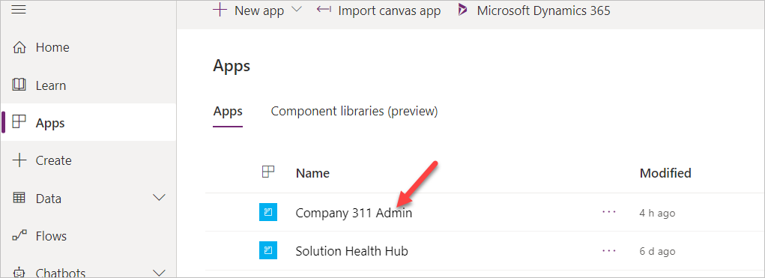](https://github.com/MicrosoftLearning/PL-100-Microsoft-Power-Platform-App-Maker/blob/master/Instructions/Labs/02-2/media/image21.png)

1. Select **Problem Reports** and click **+ New**.
2. You should see the business process flow stages. Enter **Dark parking lot** for **Title**, select **London Paddington** for **Building**, enter **There are no lights at the north end of the parking lot** for **Details**, and click **Save**.

[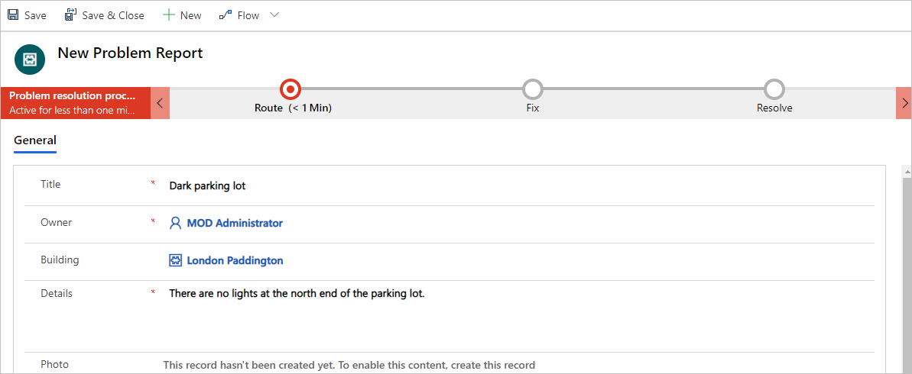](https://github.com/MicrosoftLearning/PL-100-Microsoft-Power-Platform-App-Maker/blob/master/Instructions/Labs/02-2/media/image22.png)

1. Click on the **Route** stage.

[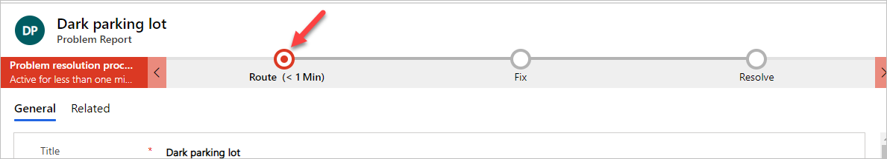](https://github.com/MicrosoftLearning/PL-100-Microsoft-Power-Platform-App-Maker/blob/master/Instructions/Labs/02-2/media/image23.png)

1. Enter **North-end** for **Location**, select **Facility Maintenance** for **Department** and select the **Next stage** stage.

**NOTE**

If the Next Stage option is not visible, then refresh the page.

[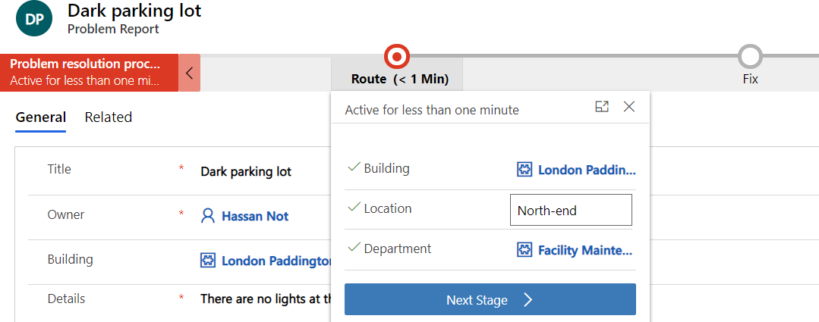](https://github.com/MicrosoftLearning/PL-100-Microsoft-Power-Platform-App-Maker/blob/master/Instructions/Labs/02-2/media/image24.png)

1. Select a user for **Assign to** and click **Next stage**.
2. Select date and time for the **Resolved on** and leave the **Resolution** value empty.
3. Scroll down to the resolution details section and select **Completed** for **Status Reason**. You should see the business rule error message.

[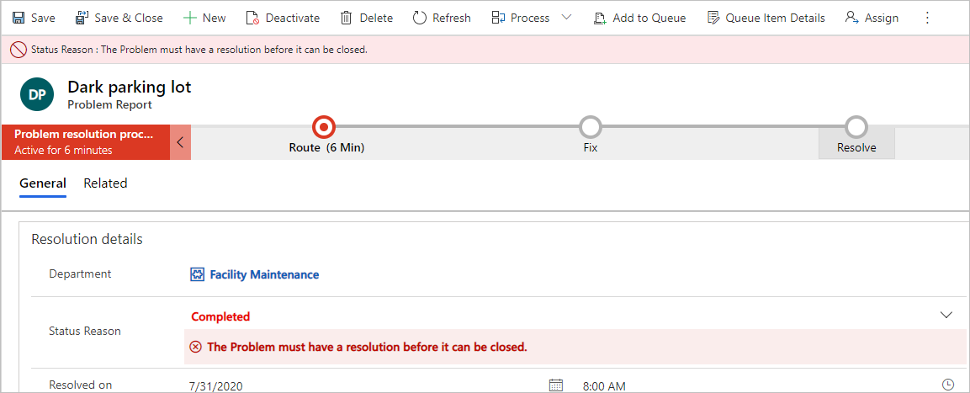](https://github.com/MicrosoftLearning/PL-100-Microsoft-Power-Platform-App-Maker/blob/master/Instructions/Labs/02-2/media/image25.png)

1. Provide **Resolution**. The error message should go away.

[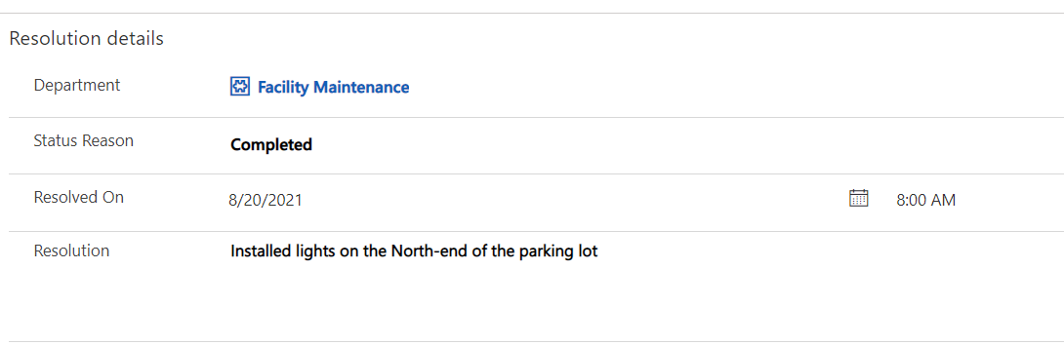](https://github.com/MicrosoftLearning/PL-100-Microsoft-Power-Platform-App-Maker/blob/master/Instructions/Labs/02-2/media/image26.png)

1. **Save** the Row.